**Frequency, Cycle, Wavelength, Amplitude and Phase**

## FREQUENCY

RF Frequency is a electromagnetic wave using AC (Alternating Current).

Just as the name implies, "frequency", its something that happens over and over and over again. It is very frequent, consistent, and repetitive.

There are different types of frequency; light, sound and in our case radio frequency (RF).

"*Frequency is the number of times a specified event occurs within a specified time interval. A standard measure of frequency is hertz (Hz)" - The CWNA definition of frequency v106*

This specified event mentioned in the CWNA Study Guide is the cycle.

## CYCLE

"*An oscillation, or cycle, of this alternating current is defined as a single change from up to down to up, or as a change from positive, to negative to positive." - The CWNA definition of cycle v106*

Lets look at a few examples of a Cycle. Example 1 - (1) Cycle

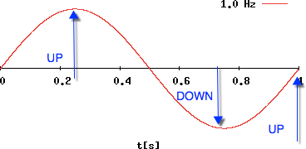

One cycle, specified event, is measured 1 second in time which equals 1 Hz. As the CWNA mentioned, "alternating current is defined as a single change from up to down to up, or as a change from positive, to negative to positive"

Example 2 - (5) Cycles

Five cycles, specified events, measured 1 second in time which equals 5 Hz.

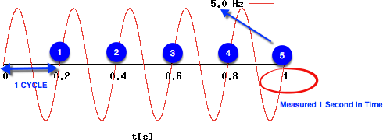

We are dealing with simple math - 1 and 5 cycles per second. Imagine for a moment 2,400,000,000 / 5,000,000,000 billion cycles in 1 second. Thats a lot of cycles, eh ? That is the number of cycles 2.4 GHz and 5 GHz (WiFi) uses to transport data from one radio over the air to another radio.

High frequency simple means there are more cycles per second. Example 3 - Low and High frequency example

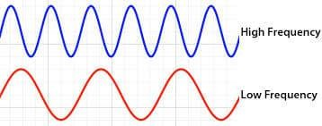

So — Remember —- Frequency is simply something that repeats itself over and over again. It is measured in cycles per seconds. The more cycles per second, the more **frequency or referenced as higher frequency.**

**WAVELENGTH** *"Wavelength is the distance between similar points on two*

*back-to-back waves." - The CWNA definition of Wavelength v106*

RF Waves can be measured at different points. In the below example, reference #1 is the most often way wavelength is measured.

Example 4

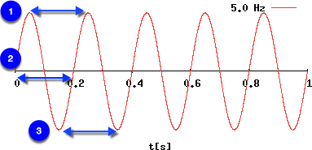

## AMPLITUDE

*"Amplitude is the height, force or power of the wave" - The CWNA definition of Amplitude v106*

What is important to remember — frequency, cycle and wavelength remain constant, however, the hight of the wave form is dynamic based on the power of the wave. The higher power, or amplitude, the higher the wave form peeks. The lower the power, or amplitude, the lower the wave form peeks all while frequency, cycle and wavelength remain the same.

Example 5 - Amplitude shown by the hight or peeks of the wave form.

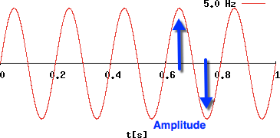

## PHASE

Phase is the same frequency, same cycle, same wavelength, but are 2 or more wave forms not exactly aligned together.

*"Phase is not a property of just one RF signal but instead involves the relationship between two or more signals that share the same frequency. The phase involves the relationship between the position of the amplitude crests and troughs of two waveforms.*

*Phase can be measured in distance, time, or degrees. If the peaks of two signals with the same frequency are in exact alignment at the same time, they are said to be in phase. Conversely, if the peaks of two signals with the same frequency are not in exact alignment at the same time, they are said to be out of phase." - The CWNA definition of Phase v106*

Example 6

Below is an example of 2 wave forms 90 degree out of phase.

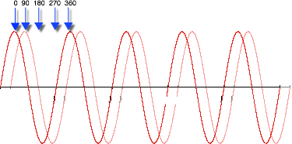

*"What is important to understand is the effect that phase has on amplitude when a radio receives multiple signals. Signals that have 0 (zero) degree phase separation actually combine their amplitude, which results in a received signal of much greater signal strength, potentially as much as twice the amplitude. If two RF signals are 180 degrees out of phase (the peak of one signal is in exact alignment with the trough of the second signal), they cancel each other out and the effective received signal strength is null.*

*Phase separation has a cumulative effect. Depending on the amount of phase separation of two signals, the received signal strength may be either increased or diminished. The phase difference between two signals is very important to understanding the effects of an RF phenomenon known as multipath, " - The CWNA definition of Phase v106*

# Peak vs. Average vs. RMS Voltage

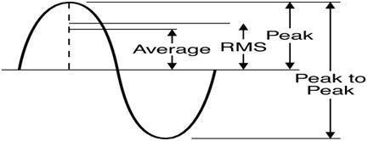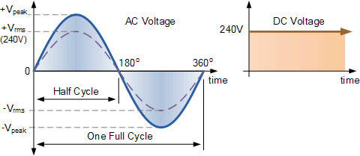

The term "RMS" stands for "Root-Mean-Squared", also called the AC equivalent to DC voltage.

The term "RMS" stands for "Root-Mean-Squared", also called the effective or heating value of alternating current, is equivalent to a DC voltage that would provide the same amount of heat generation in a resistor as the AC voltage would if applied to that same resistor.

RMS is not an "Average" voltage, and its mathematical relationship to peak voltage varies depending on the type of waveform. The RMS value is the square root of the mean (average) value of the squared function of the instantaneous values.

Since an AC voltage rises and falls with time, it takes more AC voltage to produce a given RMS voltage than it would for DC. For example, it would take 169 volts peak AC to achieve 120 volts RMS (.707 x169).

In this example, the heating value of the 169 AC voltage is equivalent to that of a 120 volt DC source. Most multi-meters, either voltmeters or ammeters, measure RMS value assuming a pure sinusoidal waveform.

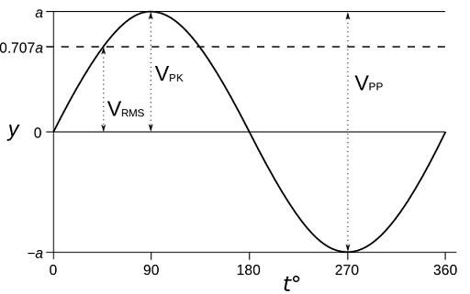

**Peak Voltage (Vp)**

The maximum instantaneous value of a function as measured from the zero-volt level. For the waveform shown above, the peak amplitude and peak value are the same, since the average value of the function is zero volts.

**Peak-to-Peak Voltage (Vp-p)**

The full voltage between positive and negative peaks of the waveform; that is, the sum of the magnitude of the positive and negative peaks.

**RMS Voltage (Vrms)**

The root-mean-square or effective value of a waveform.

**Average Voltage (Vavg)**

The level of a waveform defined by the condition that the area enclosed by the curve above this level is exactly equal to the area enclosed by the curve below this level.

**Important Equations to Remember**

* Vrms=Vp x0 .707
* Vp=1.414 x Vrms
* Vavg=0 .637 x Vp

### What is Radio Frequency

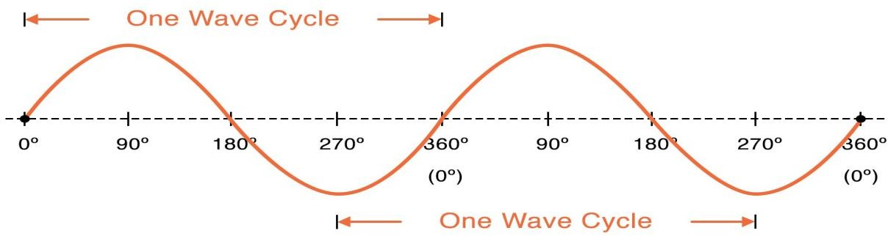

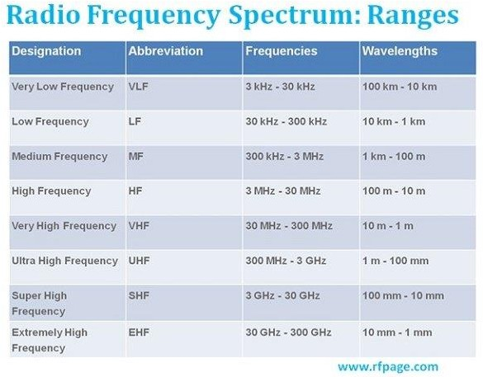

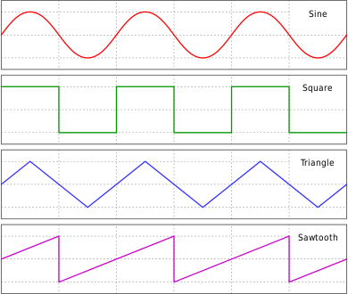

**Harmonics are multiples of the fundamental frequency.**

So if the fundamental frequency is 100 Hz, the higher harmonics will be 200 Hz, 300 Hz, 400 Hz, 500 Hz, and so on. If the fundamental frequency were 220 Hz, the harmonics would be 440 Hz, 660 Hz, 880 Hz, and so on.

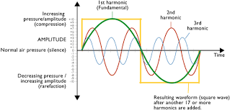

**INDUCTOR**

The **inductor** is a basic circuit element used in electrical and electronic circuits to introduce inductance. It is a passive circuit element that can store electrical energy in the form of magnetic field. A simple inductor is constructed by twisting a conductor wire of finite length in the form of a winding. In this article, I will explain all the concepts related to inductor, such as the definition of inductor, the function of inductor, the types of inductors, inductor symbol, and applications of inductors. So, let’s start with the basic definition of inductor.

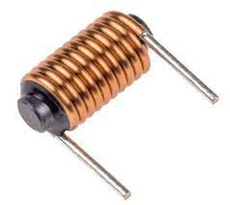

## What is an Inductor?

An **inductor** is an electronic circuit component used to introduce inductance in a circuit. It is a passive circuit component that is used to store electrical energy in the form of a magnetic field.

The most important characteristic of an inductor is that it opposes any change in the amount and direction of the circuit flowing through it. In other words, the [current](https://electricalvani.com/electric-current) through an inductor cannot change suddenly.

A simple inductor is basically a coil of a conductor wire of finite length.

## Function of Inductor

An inductor is a coil of a conductor wire. The primary function of an inductor is to introduce inductance in the circuit.

When an inductor is connected in a circuit, it prevents sudden changes in the amount and direction of the current.

An inductor can strengthen the magnetic effect of electric current. Hence, it is also used to produce strong magnetic fields like in an induction motor.

## Construction of Inductor

An inductor is constructed by winding a conductor wire on a material called the core of the inductor. When there is no core used in the inductor construction, then it is called an air core inductor.

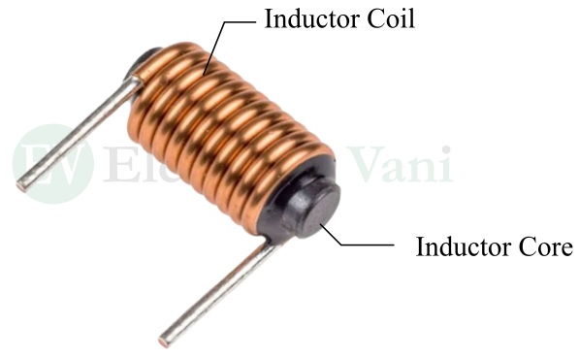

Hence, an inductor has two main parts namely, coil and core. The core of an inductor can be made up of any material like iron, steel, etc. The coil is made of a conductor wire like copper wire.

## Types of Inductors

Depending on the type of core material, inductors can be classified into the following types:

* Air Core Inductor
* Iron Core Inductor
* Ferrite Core Inductor

Inductors can also be classified based on their inductance value as follows:

* Fixed Inductor
* Variable Inductor

Let us discuss each of these types of inductors in detail.

### ****(1). Air Core Inductor:****

The **air core inductor** is a simple coil of conductor wire. This type of inductor does not have any core at the center of the coil. Air core inductors are used where a low inductance value is required. The important feature of air core inductors is that they do not have core losses.

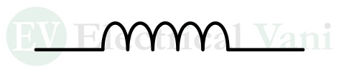

### ****(2). Iron Core Inductor:****

When the core of the inductor is made up of iron, then the inductor is called an **iron core inductor**.



Iron core inductors are used in applications where a high inductance value is desired. These inductors are able to handle high powers.

### ****(3). Ferrite Core Inductor:****

A **ferrite core inductor** is one whose core is made of ferrite materials, like Fe2O4.



The ferrite core inductors are also classified into two types namely, soft ferrite core inductor and hard ferrite core inductor. The soft ferrite core inductors are used where the reversal of magnetic polarity is desired, while the hard ferrite core inductors are used where the magnetic polarity remains constant.

### ****(4). Fixed Inductor:****

A type of inductor whose inductance cannot be changed is called a **fixed inductor**. It is a simple coil of a finite number of turns of a conductor wire.



### ****(5). Variable Inductor:****

A type of inductor whose inductance can be changed within a specified range is called a **variable inductor**.



A variable inductor has a mechanism to change its inductance. For example, the inductance can be changed by moving the core of the inductor.

## Inductors in Series

We can connect multiple inductors in series to obtain a higher inductance value. In series, the inductors are connected in a straight chain, end-to-end.

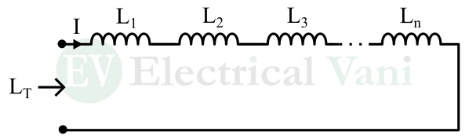

The total inductance of the inductors connected in series is given by,

LT=L1+L2+L3+⋯+Ln

Here, LT is the total inductance of the series combination of inductors, and Ln is the inductance of the nth inductor in the series combination.

## Inductors in Parallel

When multiple inductors are connected such that one end of all the inductors is connected to one point and the other of all the inductors is connected to another common point, then the inductors are said to be in parallel.

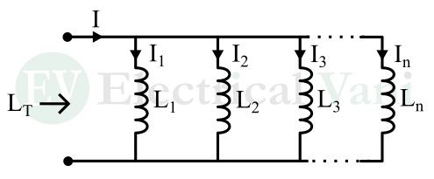

In a parallel combination of inductors, the number of branches is equal to the number of inductors connected in parallel. The voltage across all the inductors is the same and equal to the total supply voltage.

The total inductance of inductors connected in parallel is given by,

1LT=1L1+1L2+1L3+⋯+1Ln

## Applications of Inductors

As mentioned above, an inductor is a passive circuit component used to introduce inductance in a circuit. It is widely used in various electrical and electronic circuits.

Some common applications of inductors are given below:

* In tuning circuits, the inductor is used to select the desired frequency of the signal.
* The inductor is used in sensors to implement automated operations.
* The inductor is also used to store electrical energy in the form of a magnetic field for a short period.
* The inductor is used to design electromagnets.
* In electric motors, the inductor is used to convert electrical energy into mechanical energy to drive mechanical loads.
* In electric generators, the inductor is used to convert mechanical energy into electricity.
* The inductor is also used to filter unwanted signals or noise like the ripples from the output of a rectifier.
* In electronic cables, the inductor is used as a ferrite bead to reduce radio frequency interference.

### What is Inductive Reactance?

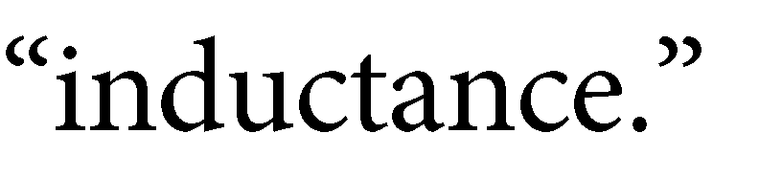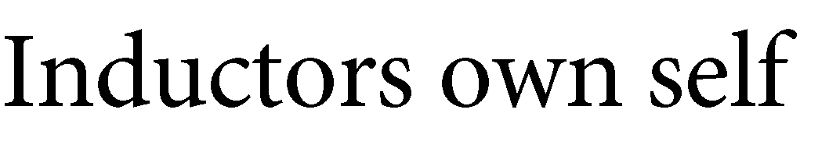

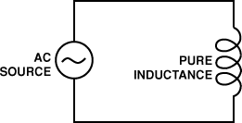

**Solved Examples for Inductive Reactance Formula**



